Lab 2 and 3:
Digital Image Processing:

Relationship between pixels:
4-adjacency:
8-adjacency:
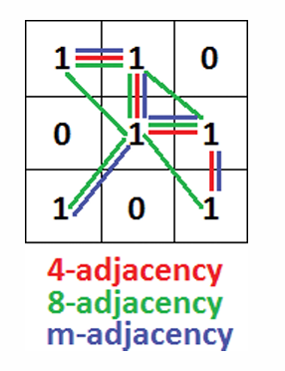

Convolution:
- Correlation is a process of moving the filter mask over the image and computing the sum of products at each location.
- Kernal is flipped by 180 degrees
Correlation:
Correlation is a process of moving the filter mask over the image and computing the sum of products at each location.
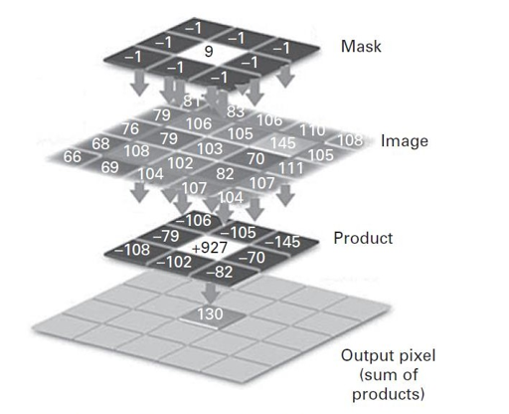

Special Filters:
Averaging Filters:
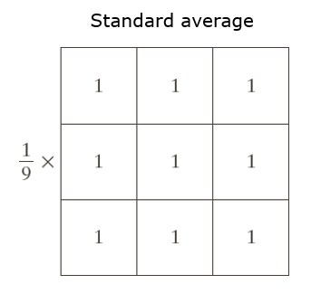

Median Filters:
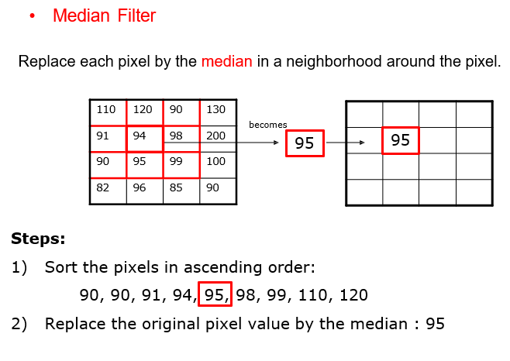

TASK:
- Find the size of an image before and after applying sampling .
- Find the m-adjacency using concepts of 4-adjacency and 8-adjacency.
- Practical implementation of finding adjacencies.
- What are special filters.
- In the given code we have use Kernal/mask/filter array defines a simple Laplacian filter for edge detection in the convolution , you have to use some other filter.
- Apply all the filter and observe effect of image.
- Apply different size of Kernal at least 2 different filters on same image.

